COMM P103: Example Audience Analysis Results and Findings

Results:
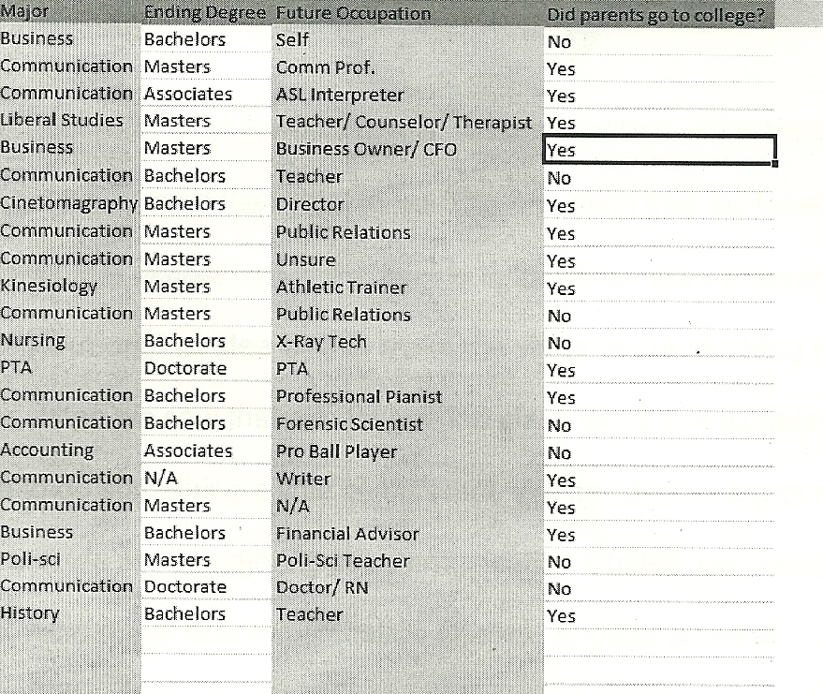

Major Findings: